**Database management systems**

**Name: Girish S Roll No: AM.EN.U4AIE22044**

# **22AIE303 – Labsheet 1**

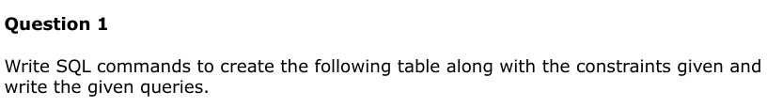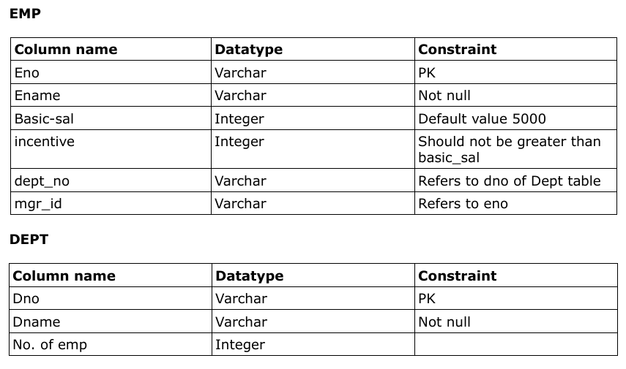

CREATE TABLE EMP ( eno VARCHAR PRIMARY KEY,   
 ename VARCHAR NOT NULL,   
 basic-sal INT DEFAULT '5000',   
 incentive INT CHECK(incentive <= basic_sal),   
 dept_no VARCHAR,   
 mgr_id VARCHAR,   
 FOREIGN KEY dept_no REFERENCES DEPT(dno),   
 FOREIGN KEY mgr_id REFERENCES EMP(eno) );

CREATE TABLE DEPT( dno VARCHAR PRIMARY KEY,   
 dname VARCHAR NOT NULL,   
 no_of_employees INT );

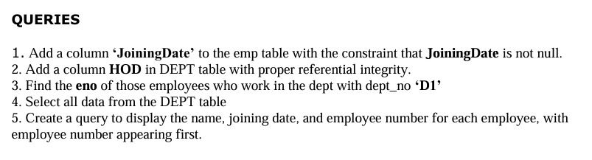

ALTER TABLE EMP ADD JoiningDate DATE NOT NULL;  
ALTER TABLE DEPT ADD HOD VARCHAR, ADD FOREIGN KEY (HOD) REFERENCES EMP(eno);  
SELECT eno FROM EMP WHERE dept_no = 'D1';  
SELECT * FROM DEPT;  
SELECT eno, ename, joiningdate FROM EMP;

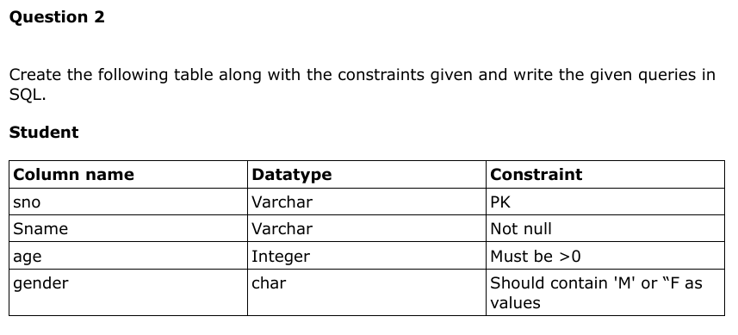

CREATE TABLE STUDENT( sno VARCHAR PRIMARY KEY,   
 sname VARCHAR NOT NULL,   
 age INT CHECK(age > 0),   
 gender CHAR CHECK(gender IN ('M','F')) )

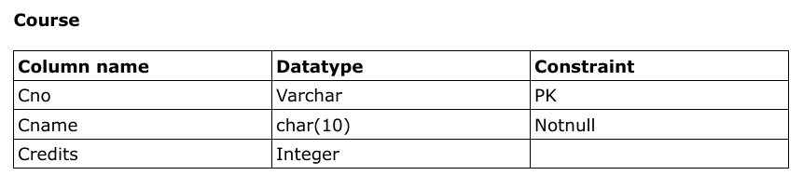

CREATE TABLE COURSE( cno VARCHAR PRIMARY KEY,   
 canme CHAR(10) NOT NULL,   
 credits INT );

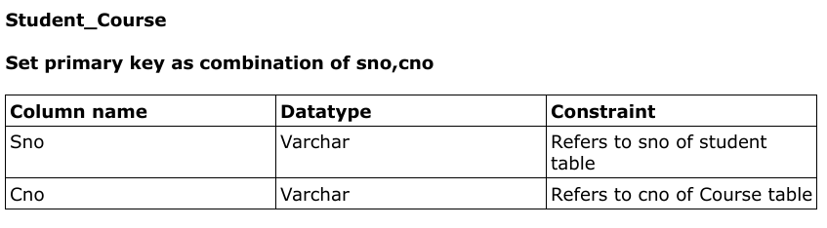

CREATE TABLE Student_Course ( sno VARCHAR,   
 cno VARCHAR,   
 PRIMARY KEY (sno, cno),   
 FOREIGN KEY (sno) REFERENCES STUDENT(sno),   
 FOREIGN KEY (cno) REFERENCES COURSE(cno) );

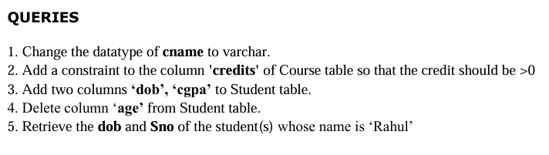

ALTER TABLE COURSE ALTER COLUMN cname TYPE VARCHAR;  
ALTER TABLE COURSE ADD CONSTRAINT check_credits CHECK(credits > 0);  
ALTER TABLE Student ADD COLUMN dob DATE, ADD COLUMN cgpa DECIMAL;  
ALTER TABLE STUDENT DROP COLUMN age;  
SELECT dob, sno FROM STUDENT WHERE sname = 'Rahul';

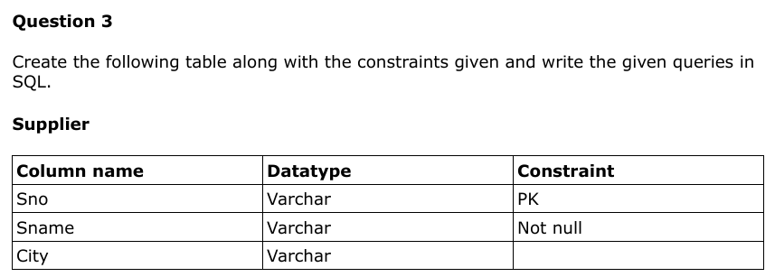

CREATE TABLE supplier( sno VARCHAR PRIMARY KEY,   
 sname VARCHAR NOT NULL,   
 CITY VARCHAR );

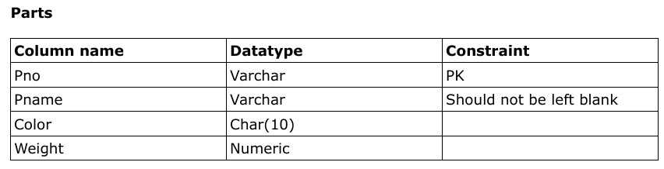

CREATE TABLE parts( pno VARCHAR PRIMARY KEY,   
 pname VARCHAR NOT NULL,   
 color CHAR(10),   
 weight NUMERIC );

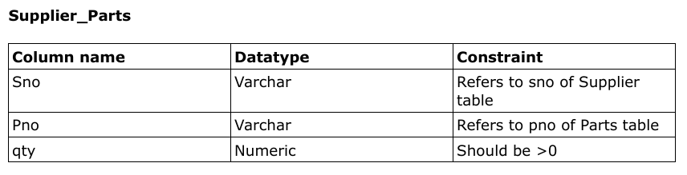

CREATE TABLE supplier_parts( sno VARCHAR,   
 pno VARCHAR,   
 qty NUMERIC CHECK (qty > 0),   
 FOREIGN KEY (sno) REFERENCES supplier(sno),   
 FOREIGN KEY (pno) REFERENCES parts(pno) );

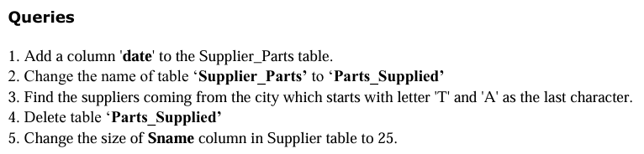

ALTER TABLE supplier_parts ADD COLUMN date DATE;  
ALTER TABLE supplier_parts RENAME TO parts_supplied;  
SELECT sname FROM supplier WHERE city LIKE 'T%A';  
DROP TABLE parts_supplied;  
ALTER TABLE supplier ALTER COLUMN sname TYPE VARCHAR(25);

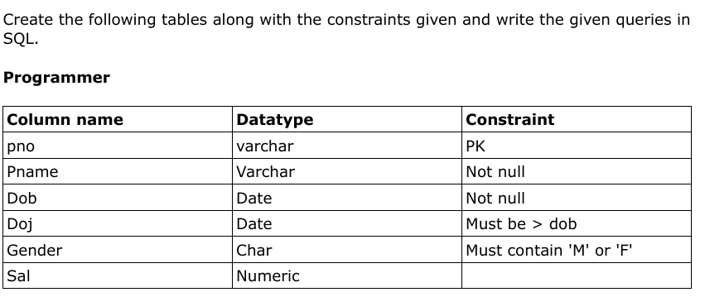

CREATE TABLE programmer( pno VARCHAR PRIMARY KEY,   
 pname VARCHAR NOT NULL,   
 dob DATE NOT NULL,   
 doj DATE NOT NULL,   
 gender CHAR,   
 sal NUMERIC,   
 CONSTRAINT doj_check CHECK(doj > dob),   
 CONSTRAINT gender_check CHECK(gender IN('M','F')) );

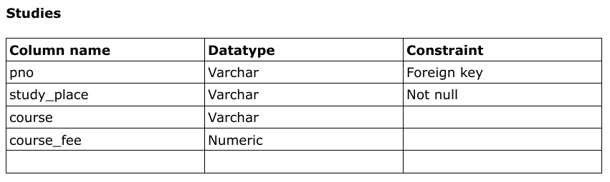

CREATE TABLE studies( pno VARCHAR,   
 study_place VARCHAR,   
 course VARCHAR,   
 course_fee NUMERIC,   
 FOREIGN KEY(pno) REFERENCES programmer(pno) );

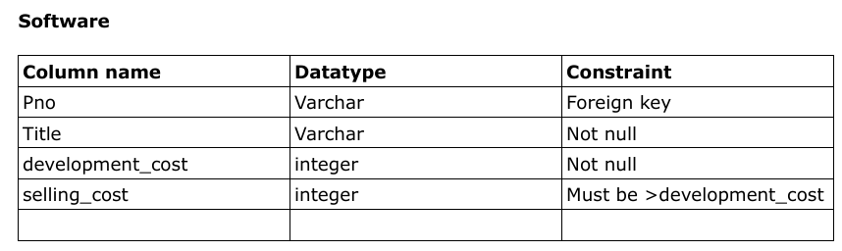

CREATE TABLE software( pno VARCHAR,   
 title VARCHAR NOT NULL,   
 development_cost INT NOT NULL,   
 selling_cost INT,   
 FOREIGN KEY (pno) REFERENCES programmer(pno),   
 CONSTRAINT selling_check CHECK(selling_cost > development_cost) );

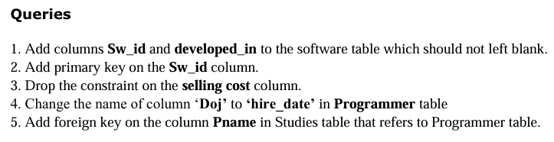

ALTER TABLE software ADD COLUMN sw_id VARCHAR NOT NULL, ADD COLUMN developed_in VARCHAR NOT NULL;  
ALTER TABLE software ADD CONSTRAINT prime PRIMARY KEY(sw_id);  
ALTER TABLE software DROP CONSTRAINT selling_check;  
ALTER TABLE programmer RENAME COLUMN doj TO hire_date;